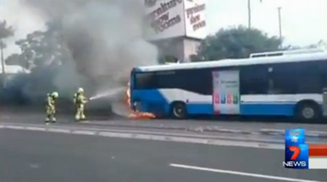
Three buses on fire in Sydney in three months
Fire suppressant systems an urgent priority

Recently a bus full of passengers caught fire on Parramatta road. This was the third in a string of similar incidents in the past three months.

The RTBU is calling on the NSW Government to make funding immediately available and urgently fit all buses in NSW with fire suppressant systems before a serious injury or death occurs.
Read more on www.busexpress.com.au

Moving forward on women’s campaigns
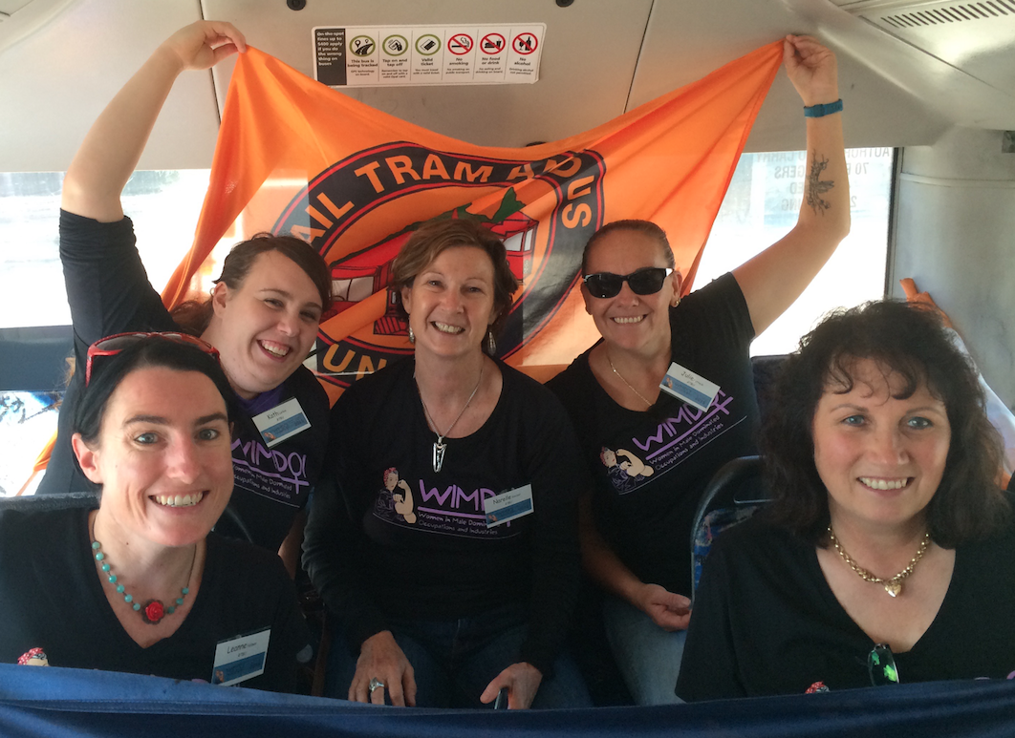
Women are vastly outnumbered in our industry - only around 8 per cent of STA employees are female.
There are many barriers in our industry which prevent the recruitment, retention and progression of women.
The RTBU’s Women’s Campaigns Committee met recently and agreed on concrete ways to improve conditions for women in our industry.
Also this month, five RTBU reps attended the Women in Male Dominated Industries conference, bringing together women from a broad range of industries. The conference offered the opportunity to share personal stories, discuss the challenges women face, and learn strategies to recruit and retain women in traditionally male workforces.
Read more on www.busexpress.com.au

Ultra Marathon For Kids
Divisional Secretary Chris Preston and Divisional President Gary Way
Bereavement/Compassionate leave
59.1 An employee is entitled to up to two days paid leave, on each occasion if a member of the employee’s immediate family or household dies.
59.2 Each day or part of a day used under 59.1 is deducated from the amount of personal/carer’s leave under sub-clause 56.1

Vice President Brett Peters

Know your Rights
RTBU member and bus driver from Leichhardt depot, Matthew Reid
will run from Melbourne to Sydney in September to raise money.

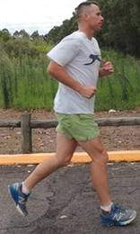
Matthew’s been busy training and has begun to ask for donations and organise fundraising events. His goal is to raise $500,000 for the Starlight Foundation.

“I love kids and have an 8 year old son and would do anything to help kids. That’s why I chose Starlight, because the concept of parents staying with their kids in Hospital rings true to me. That the sick kids and their parents can stay together in hospital.”

You can donate to sponsor Matthew via the link at www.busexpress.com.au or by searching for ‘Ultra Marathon for Kids’ on Facebook.

Meet Your Local Delegate

Peter Tsapepas, RTBU delegate, Waverley
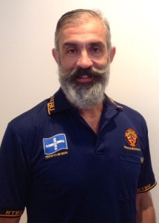
1. Why did you become involved in the Union? I was elected at the end of 2014 and I got involved to defend the rights of the workers.
2. What are your hobbies and interests? I pretend that I surf, I love to ski, I swim in the ocean and I go to the gym.
3. Where do you live and why do you like it? I live close to the city and close to the beach. I like it because of the city life and the ocean.

4. Who would you like to have dinner with (dead or alive) and why? That’s a hard one. Nelson Mandela – he went through a lot and I’d like to ask him what kept him going.

