Coming to a depot near you…
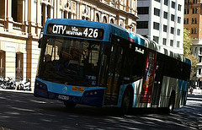
Union representatives will be visiting all bus depots in the coming weeks to ensure members are fully briefed about what's in the proposed new Enterprise Agreement.

Check with your local Delegate about when the briefing will be held in your depot.

For members unable to attend the briefing, your Delegate can answer any questions you may have individually.

It is important that all members understand what is in the proposed Agreement before the attendance ballot, which will be conducted by the Union in each depot on Friday the 26th of September between 8am and 4pm.

Please keep checking Bus Express for any updates: http://busexpress.com.au

Carers Leave Dispute
Following a long running dispute between the Union and STA about when members can use a “Statutory Declaration” for Carer’s Leave, the following arrangements were put in place during Industrial Relations Commission Proceedings: “Statutory Declarations can be used for 5 days of Carer’s Leave per year, unless you are on the Absence Management Program” (AMP).

NSW IRC Commissioner Tabba will monitor these arrangements, with a “Report Back” scheduled for around three months time. The Union is confident of a positive final outcome.
Divisional Secretary Chris Preston and Divisional President Gary Way
Articulated Bus Allowance
39.1 An employee who operates an articulated bus, shall be paid an additional amount per shift, as set out in Part B, Item 2 of Table 2, of this Award.
39.2 An employee who operates an articulated bus on 124 or more shifts in a twelve month period immediately prior to clearing paid leave, shall be paid the allowance set out in Part B, Item 2 of Table 2, of this Award, for the period of the paid leave.

Vice President Brett Peters

Know your Rights

Tram and Bus Division and STA Boss Take The Ice Bucket Challenge
Tram and Bus Divisional Secretary Chris Preston nominated National Secretary RTBU Bob Nanva and STA boss Peter Rowley to take the ice bucket challenge to raise awareness and money for Motor Neurone Disease after he had also taken on the challenge. And they did it!

For some laughs, watch all three videos at http://busexpress.com.au

Chris Preston was originally nomintated by Brookvale Delegate Narelle Sinclair.

From left: Chris Preston and Peter Rowley

Meet Your Local Delegate
Profile – Michael De Meo, RTBU Delegate for Port Botany depot
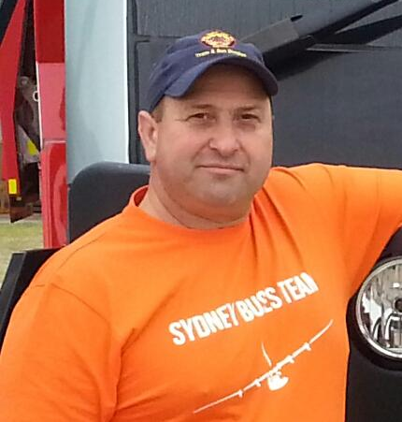
1. Why did you become involved in the union? Before STA, I was a Factory Manager in the furniture industry. I had always considered myself a team player and helped my fellow work colleagues. I believe that having 100% completion in my production required a successful and strong team who worked together. I think Port Botany is the best Depot in STA and I consider my fellow work colleagues like a family, as I spend 12 to 14 hours of the day at work. I believe in a fair workplace where everyone is treated equally. And besides, who wouldn't help family if they were in trouble?
2. What are your hobbies and interests? Going fishing, soccer (Italy to win the next world cup), taking my kids to soccer and watching them play, spending time with my family and helping my kids with their homework.
3. Who would you like to have dinner with (dead or alive) and why? My wife
and children because life is short and every moment together is like gold.

